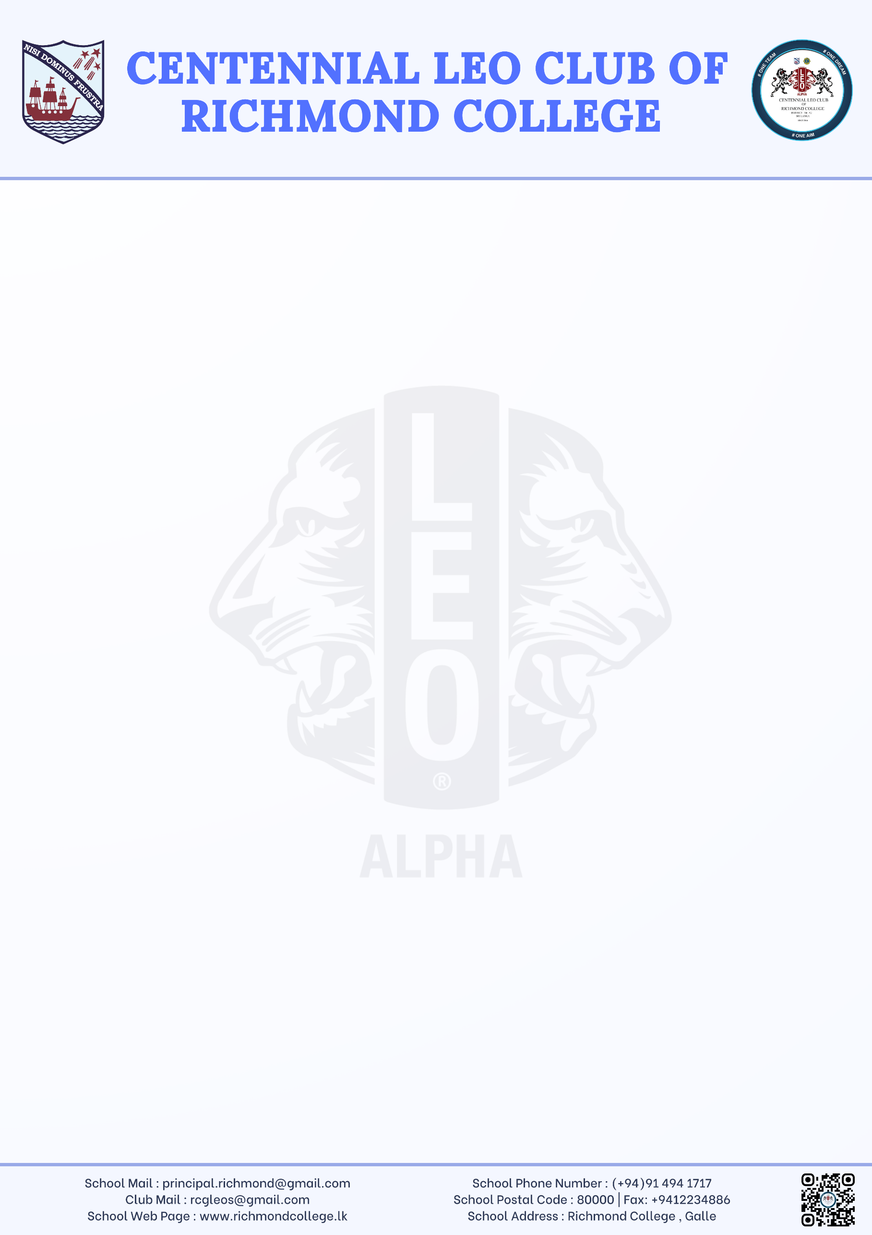
LEO CLUB OF RICHMOND COLLEGE, GALLE
Richmond College, Galle
09.23.2025
Principal
Richmond College, Galle
Dear Sir,

We, the Leo Club of Richmond College, Galle, are planning to hold our 10th Installation Ceremony and 10th Anniversary Celebration. Before finalizing the date, we kindly seek your availability and guidance.
The proposed dates are as follows:
- 20th October 2025
- 25th October 2025
- 05th November 2025
We would be most grateful if you could inform us of your convenience, so we may proceed with the arrangements accordingly.
Thank you for your kind consideration.
Yours faithfully,

………………………………………
Mevinu Sanuka Narawela Gamage
President – Leo Club
Richmond College, Galle

………………………………………
Ms. Sanduni Kodituwakku
Staff Advisor – Leo Club
Richmond College, Galle

